Desk & Member Utilisation Tracker – CRUD Web App for CoCreate North

Programming for Information Systems (B9IS123)
Gourav Sankar Ray | 20070234 | Dublin Business School
Lecturer: Paul Laird

Company Overview - CoCreate North

Coworking space offering hot desk, dedicated desk, private office and corporate workspace services.

Location: O’Connell Street Upper, Dublin 1

The objective is to replace manual booking and tracking systems with an information system that will enable more effective use of the co-working space.

Project Objective:

Develop a CRUD web-app using Javascript for FE, BE and SQL for database.

Core Modules:

Desk management
User management
Booking management
Booking status page / Check-in Screen
Reports & Analytics Screen
Settings/Configuration Screen

Features:

Create - create desk & meeting room assets, member profiles in the system
Read - read the updated booking and availability status from the remote database
Update - update the assets, members details in the system
Delete - delete assets, bookings, members data from the remote database

- Desk booking and management
- Utilisation dashboard consisting of charts, heatmap
- Metrics like occupancy %, member activity
- Manage master data and system setup
  - Add/Edit Booking Durations (first half, second half, full day)
  - Manage Zones (names, floors, descriptions)

ER Diagram

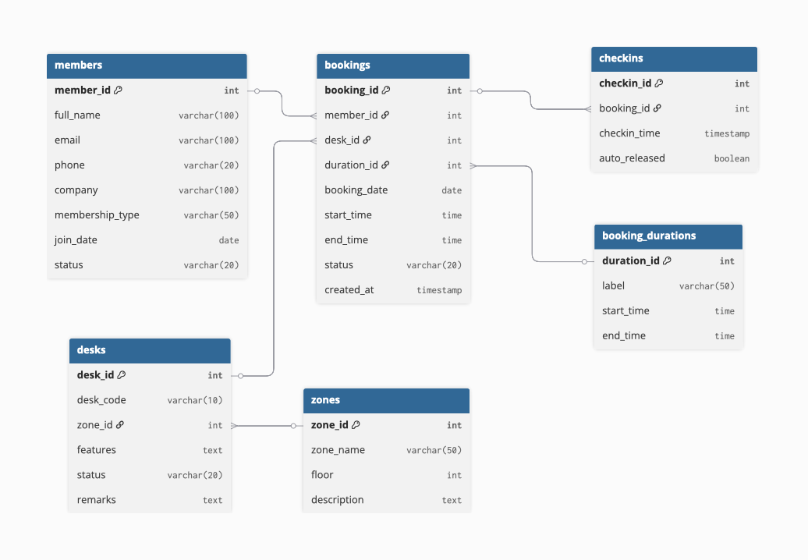

Tools & Technologies:

Frontend: React (or HTML, CSS, JS)
Backend: Node.js + Express
Database: SQL
Version Control: GitHub
Documentation: Google Docs (Editor access)

Early Prototype & API Setup:

